# Apply filters to SQL queries

## Project description

This document outlines SQL queries designed to filter data based on specific criteria for login attempts and employee records. The goal is to investigate potential security breaches and efficiently retrieve relevant information for analysis and reporting.

## Retrieve after hours failed login attempts

To help investigate the potential security incident that occurred after business hours an SQL query was written to fetch all login attempts that occurred after business hours. The following SQL command queries the **log_in_attempt** table and fetches all the login attempts that occurred after **16:00**.

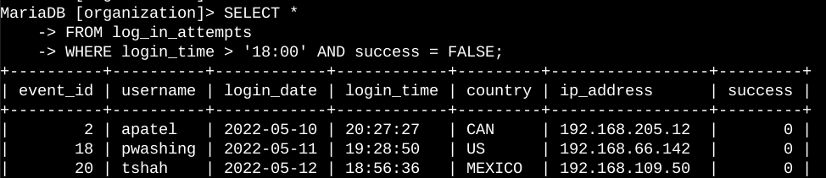

## Retrieve login attempts on specific dates

To investigate the suspicious activity that occurred on 2022-05-09. The SQL query was written to investigate login attempts that occurred on that day and the previous. The following SQL command queries the **log_in_attempt** table for all login attempts that occurred **2022-05-09** or **2022-05-08**.

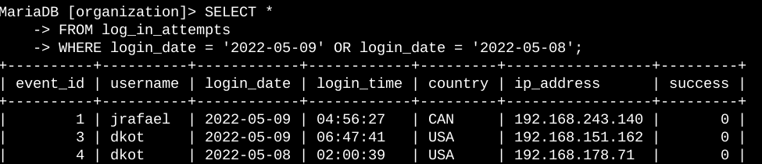

## Retrieve login attempts outside of Mexico

After further investigations on the organization's login attempts, it was determined that the issue occurred outside Mexico. The following SQL command queries the **employees** table and fetches all the login attempts that occurred outside **Mexico.**

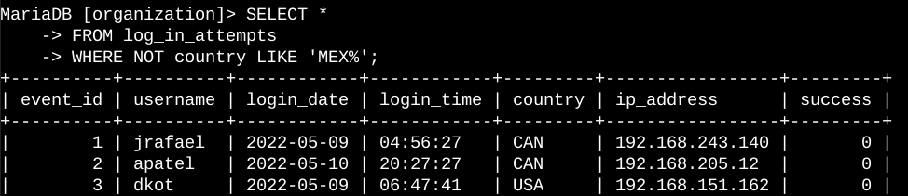

## Retrieve employees in Marketing

To perform security updates on specific employees machines in the marketing department, The following SQL command queries the **employees** table and identifies all employees in the Marketing department for all offices in the East building.

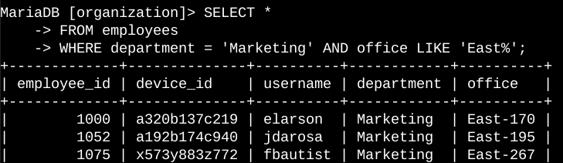

This SQL query above fetches all employee machines that need security updates based on the conditions given in the SQL query.

## Retrieve employees in Finance or Sales

To perform a different security update on machines for employees in the Sales and Finance department, The following SQL command queries the **employees** table and identifies all employees in the Sales or Finance departments.

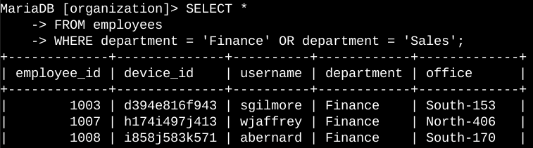

This SQL query above fetches all employee machines that need security updates based on the conditions given in the SQL query.

## Retrieve all employees not in IT

My team needs to make one more security update on employees who are not in the Information Technology department. To make the update, I first have to get information on these employees.The following SQL command queries the **employees** table and identifies all employees not in the IT department.

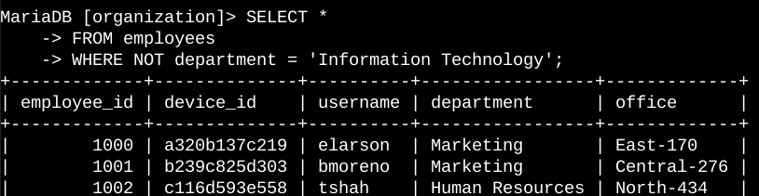

The SQL query above returns the information of all employes except employees in the IT department.

## Summary

These SQL queries provide a framework for filtering and retrieving data for failed login attempts and employee records based on various conditions. They can be adapted to accommodate additional criteria or integrated into larger reporting systems.